CONCLUSIONS
- Interpolation schemes are based on a “reference simulation” using a reference profile.
- The efficiency of the scheme strongly depends on the acquisition temporal resolution:
  - High resolution – reconstruction produces wiggles which are almost completely removed during interface interpolation. Interface region itself is greatly diminished.
  - Low resolution – characterized by a main dip, which can be interpolated in more than a single iteration (usually two).

High resolution

FID #591 – sample of ones
Sample : ones
N acquisition : 750 * 2
Reference profile : ones
Reference baseline : mean at quarter length (of 0.1 length)
Filter exp value : 15 + (iter_idx – 1) * 0 , 10
VHF filter : 3, 10
ppWinExpVal : 15
ppWinESP : 3
Iterations : 1
Iteration type : constant / incremented

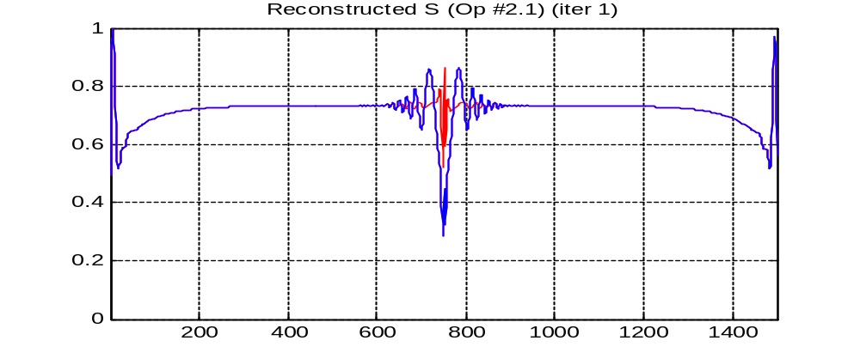
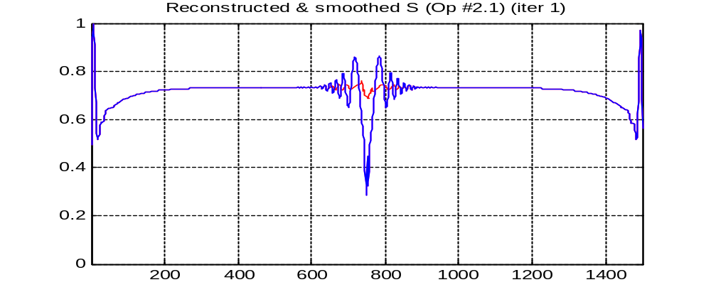
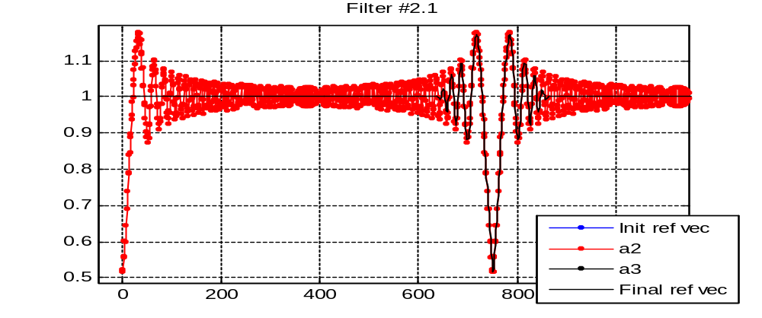
- Successful interpolation.

FID #592 – double Gaussian
Sample : double Gaussian
N acquisition : 750 * 2
Reference profile : ones
Filter exp value : 15 + (iter_idx – 1) * 0 , 10
VHF filter : 3, 10
ppWinExpVal : 15
ppWinESP : 3
Iterations : 1
Iteration type : constant / incremented

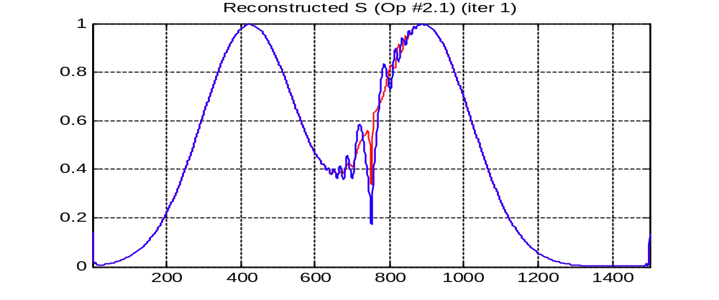
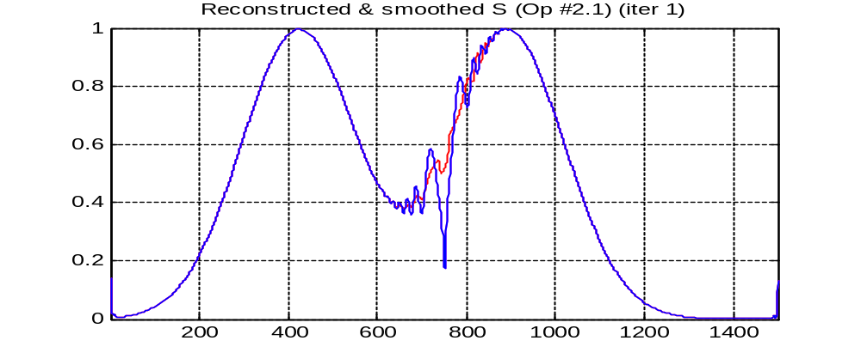
- Successful interpolation.

FID #595 – double Gaussian
Sample : double Gaussian
N acquisition : 1500 * 2
Reference profile : ones
Reference baseline : mean at quarter length (of 0.1 length)
Filter exp value : 15 + (iter_idx – 1) * 0 , 10
VHF filter : 5, 10
ppWinExpVal : 15
ppWinESP : 3
Iterations : 1
Iteration type : constant / incremented

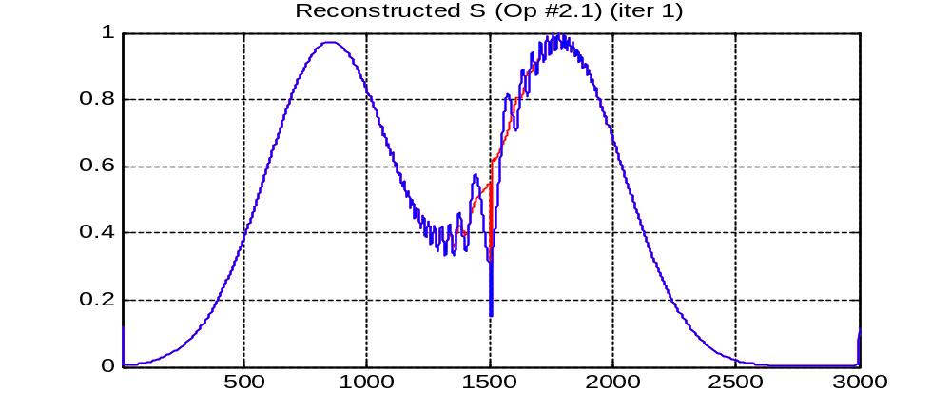
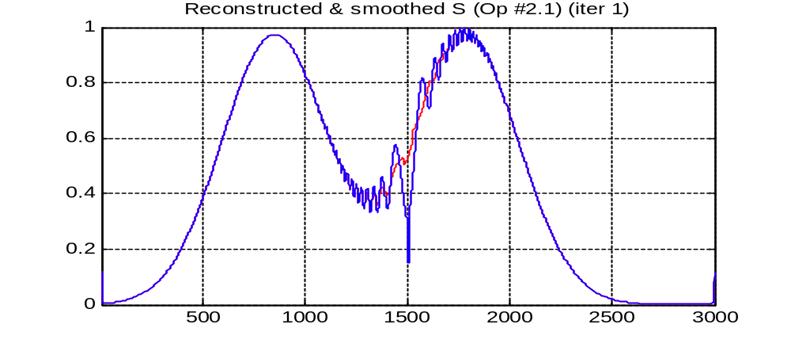
- Successful interpolation.

Low resolution

FID #596 – double Gaussian; k-space wrongly configured
Sample : double Gaussian
N acquisition : 1500 * 2
Reference profile : ones
Reference baseline : mean at quarter length (of 0.1 length)
Filter exp value : 60 + (iter_idx – 1) * 0 , 10
VHF filter : 3, 10
ppWinExpVal : 15
ppWinESP : 3
Iterations : 2
Iteration type : constant / incremented
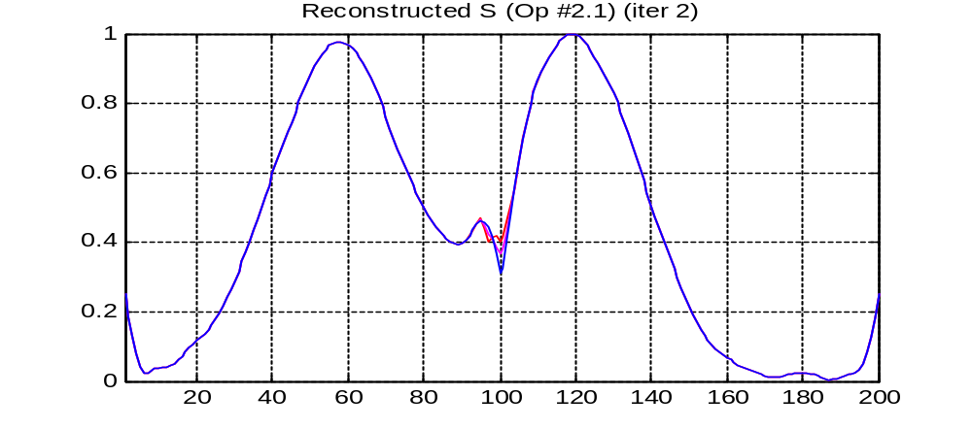
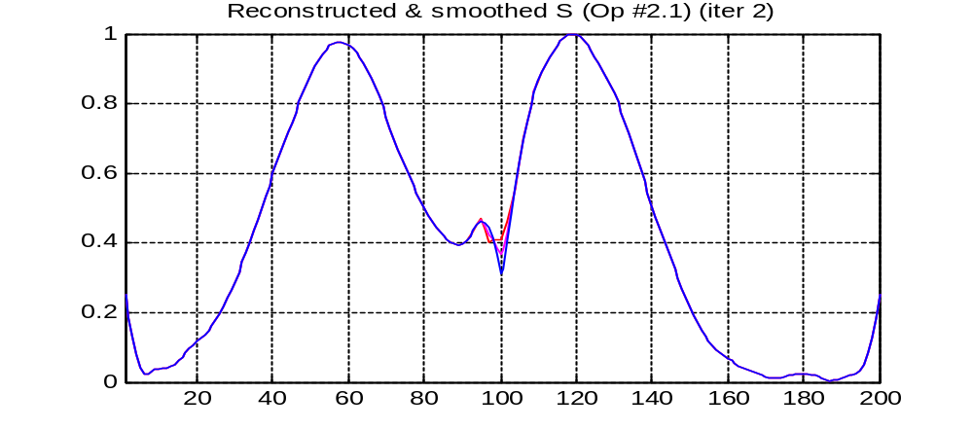
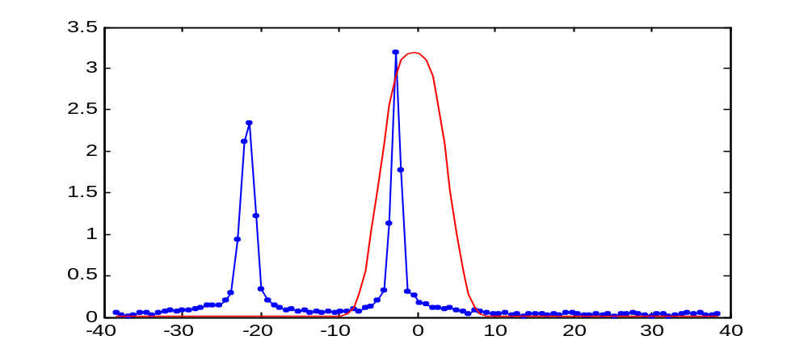

4.1 Using incremented reference profile
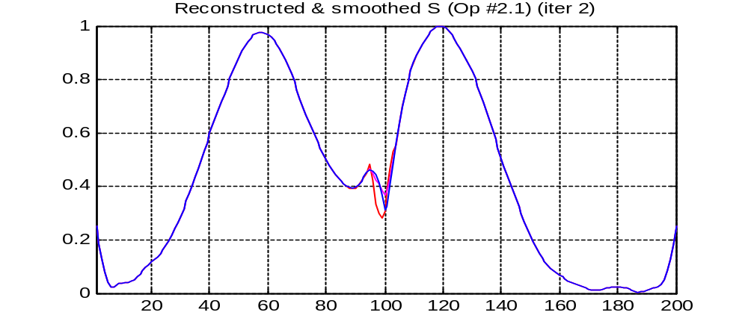

FID #596 – double Gaussian; k-space wrongly configured; using interpolated reference
Sample : double Gaussian
N acquisition : 1500 * 2
Reference profile : ones
Reference baseline : median of interpolated reference vector
Reference interp : 214 → 2000
Filter exp value : 60 + (iter_idx – 1) * 40 , 10
VHF filter : 3.5, 5
ppWinExpVal : 10
ppWinESP : 5
Iterations : 1
Iteration type : constant / incremented
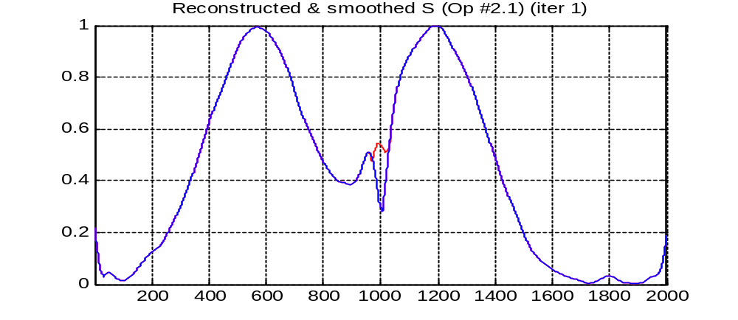

FID #597 – double Gaussian; k-space correctly configured
Sample : double Gaussian
N acquisition : 107 * 2
Reference profile : ones
Reference baseline : max of reference vector
Filter exp value : 60 + (iter_idx – 1) * 40 , 10
VHF filter : 3, 10
ppWinExpVal : 10
ppWinESP : 5
Iterations : 2
Iteration type : constant / incremented

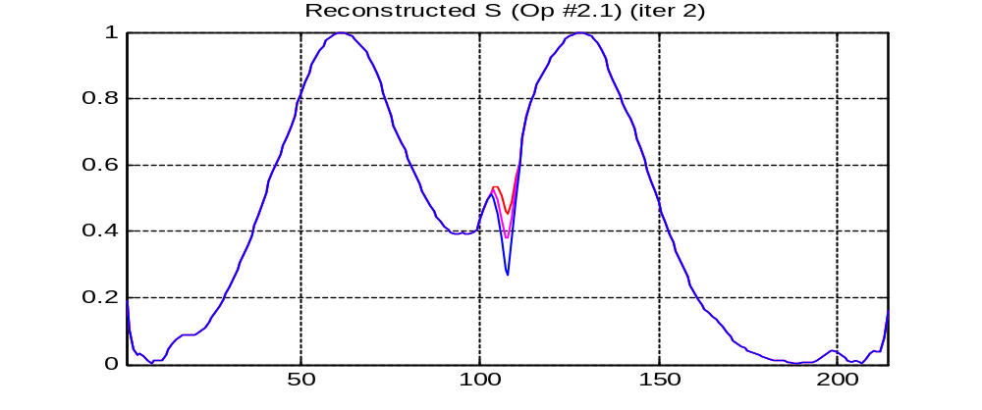
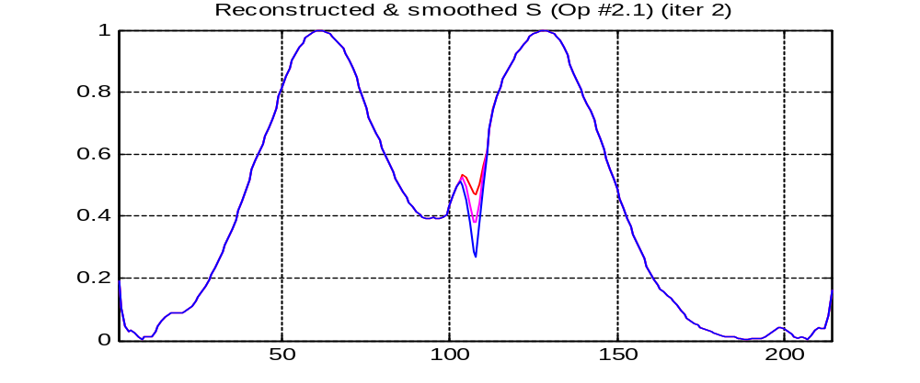
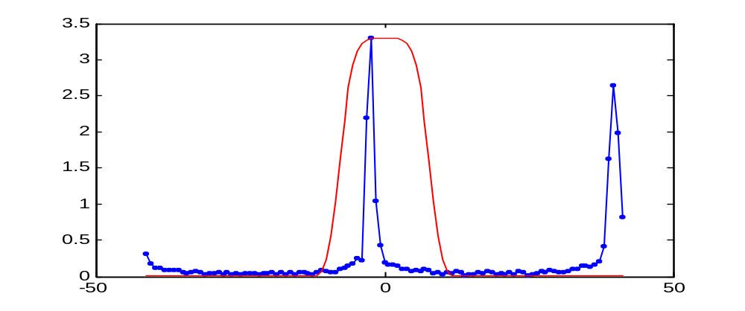
- Successful interpolation.

Low resolution; Interpolated reference vector

FID #597 – double Gaussian; high-res reference vector
Sample : double Gaussian
N acquisition : 107 * 2
Reference profile : ones
Reference baseline : median of interpolated reference vector
Reference interp : 214 → 2000
Filter exp value : 60 + (iter_idx – 1) * 40 , 10
VHF filter : 3, 10
ppWinExpVal : 10
ppWinESP : 5
Iterations : 1
Iteration type : constant / incremented

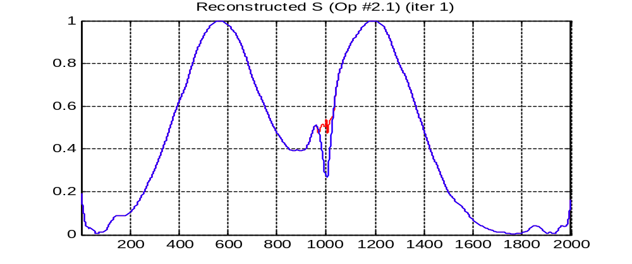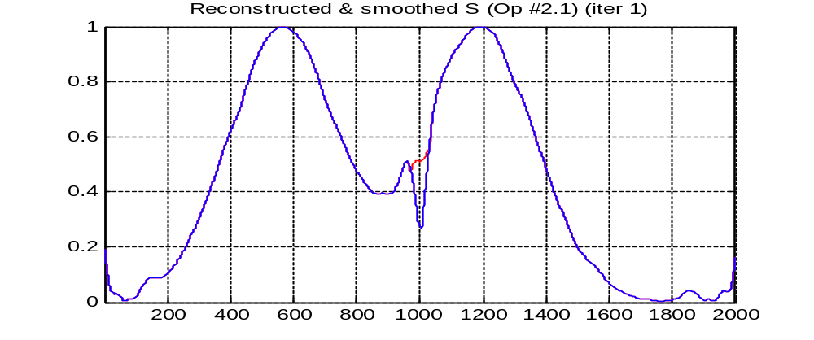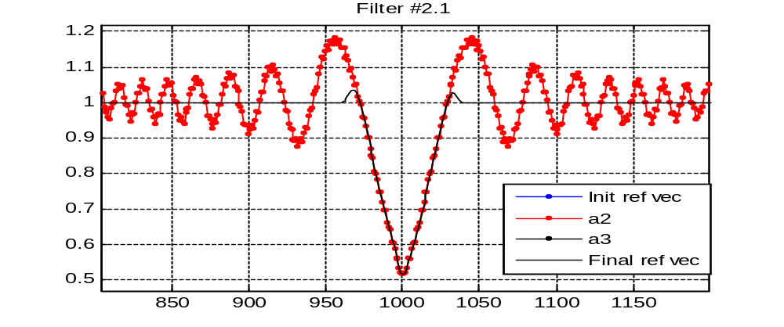
- Successful interpolation (better than w/o high-res reference) using a single iteration.

FID #598 – ones
Sample : ones
N acquisition : 107 * 2
Reference profile : ones
Reference baseline : median of interpolated reference vector
Reference interp : 214 → 2000
Filter exp value : 60 + (iter_idx – 1) * 40 , 10
VHF filter : 3, 10
ppWinExpVal : 10
ppWinESP : 5
Iterations : 1
Iteration type : constant / incremented

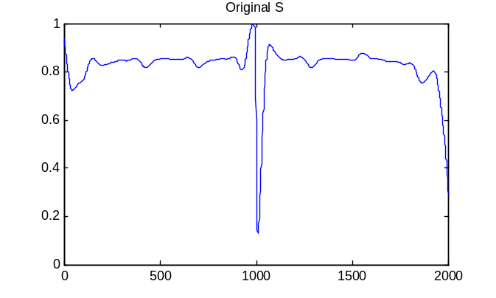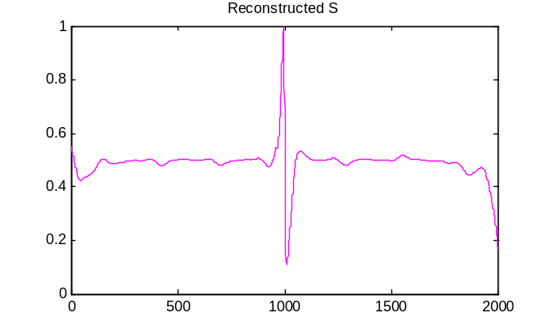
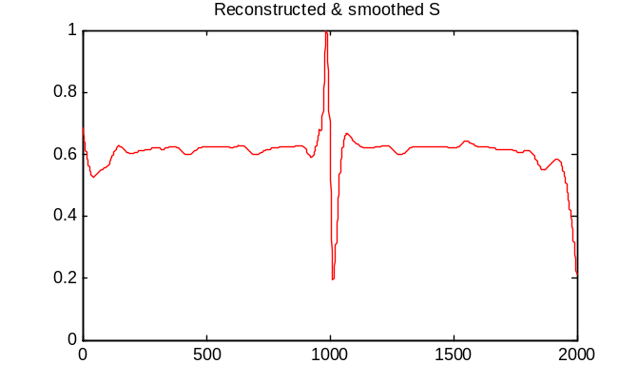
- Interpolated profile is almost as worse as the original one.

FID #600 – Rectangular
Sample : rectangular
N acquisition : 107 * 2
Reference profile : ones
Reference baseline : median of interpolated reference vector
Reference interp : 214 → 2000
Filter exp value : 60 + (iter_idx – 1) * 40 , 10
VHF filter : 3, 10
ppWinExpVal : 10
ppWinESP : 5
Iterations : 1
Iteration type : constant / incremented
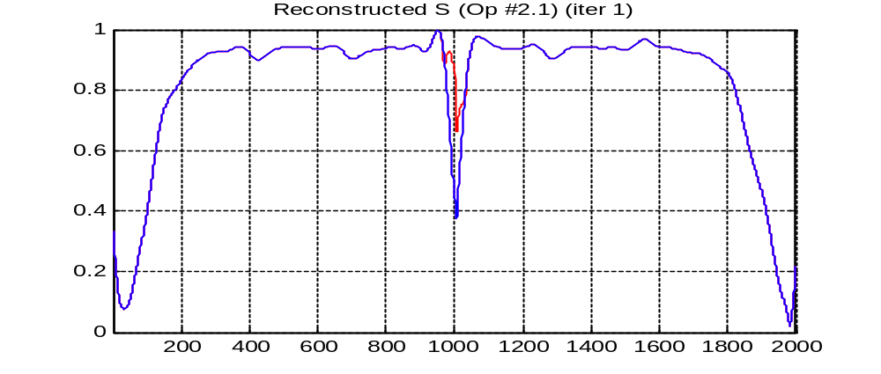
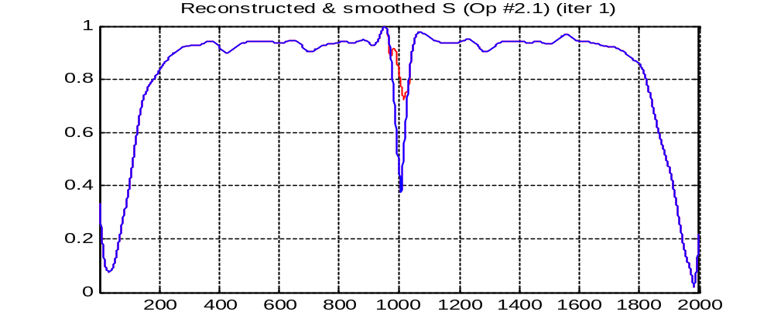
- Semi-satisfactory interpolation.
- Trying to use a rectangular reference profile gave an identical result.
- Trying to use 2 iterations gave a much worse result, inflating the ifs zone out of proportion.

